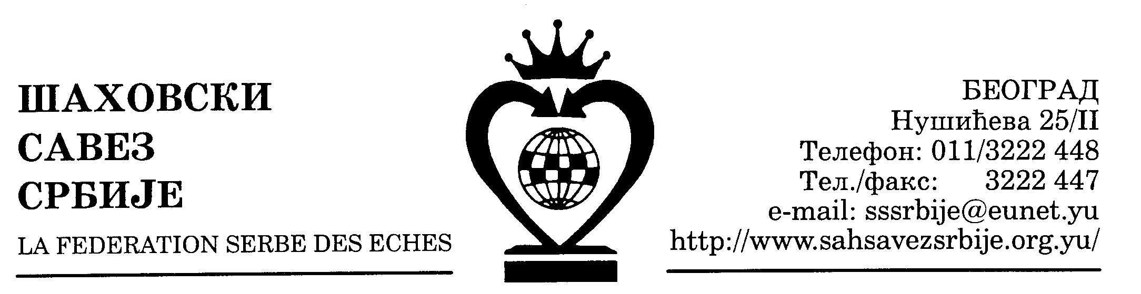 | SAHOVSKI KLUB “GOC”  Vrnjacka Banja, Cajkina b.b, Тел-факс:063-614-347; 063-698-347,  Br. ziro racuna: 160-19184-45

Vrnjacka Banja, 10. 06. 2011.
List 1/4

OSTVARENE POBEDE I REMIJI NA SIMULTANKI 04.06.2011

Red.  br. | IME I PREZIME  IZVODJACA | IME I PREZIME  IGRACA | MESTO  IGRACA | REZULT.
1. | Alisa Maric | Seizovic Zoran | Vrnj.Banja | 1/2
 |  | Manojlovic Selimir | Valjevo | 1/2
 |  | Vujic Vojislav | Vrnj.Banja | 1/2
 |  | Prvulovic Jovana |  | 1/2
 |  | Milevski Djordji | Skoplje | 1/2
2. | Vladimir Vladimirov  (Skoplje, mk) | Milosevic Jovana |  | 0:1
3. | Vladimir Kostic | Ristic Djordje | Sm.Palanka | 1/2
4. | Popovic Djordje | Karaklic Andrea | Sm.Palanka | 1/2
5. | Maksimovic Branko | Kozadicevski Pedja | Бе | 1/2
 |  | Misic Jana |  | 1/2
 |  | Djakovic Nevena |  | 1/2
 |  | Dikic Veljko |  | 1/2
 |  | Markovic Aleksandar |  | 1/2
 |  | Rekovic Mladen |  | 1/2
 |  | Nikolic Filip |  | 1/2
 |  | Stolic Irena |  | 1/2
 |  | Deljanin Ignjatije |  | 1/2
 |  | Babic Dragan |  | 0:1
 |  | Josipovic Dragan |  | 0:1
6. | Zivic Dragan | Djinovic Tijana |  | 1/2
 |  | Golubovic Marko |  | 1/2
 |  | Ljubic Nebojsa |  | 1/2
7. | Kojovic Dragan | Kostic Marko |  | 1/2
 |  | Drobnjak Veljko |  | 1/2
8. | Tosic Miroslav | Djokic Luka | Krusevac | 1/2
 |  | Brkic Hajdavi | Krusevac | 1/2
 |  | Mijatovic Bosko | Krusevac | 1/2
 |  | Brkic Ojdana | Krusevac | 1/2
 |  | Zivanovic Nevena | Krusevac | 1/2
 |  | Zivanovic Blagoje | Krusevac | 1/2
 |  | Valjarevic Mateja | Krusevac | 1/2
9. | Martinovic Slobodan | Isak Igor | Smederevo | 1/2
 |  | Jovanovic Lazar | Smederevo | 1/2
 |  | Josifovic Dimitrije | Smederevo | 1/2
 |  | Zivotic Aleksandar | Smederevo | 1/2
10. | Ivanisevic Ivan | Rajcic Andjelija |  | 1/2
 |  | Arsenijevic Ivan | Пожаревац | 1/2
11. | Milanovic Danilo | Zajic Milun | Крушевац | 1/2
 |  | Vaskovic Andjela | Параћин | 1/2
12. | Peric Slavisa | Stojanovic Nikola | Nis | 1/2
 |  | Zivadinovic Danilo | Nis | 0:1
 |  | Stamenkovic Lazar | Nis | 1/2
 |  | Marinkovic Dragan | Nis | 1/2
 |  | Stamenkovic Nikola | Nis | 1/2
 |  | Nedeljkovic Stevan | Nis | 1/2
13. | Rakic Miodrag | Stankovic Zorana | Nis | 1/2
 |  | Stankovic Nenad | Nis | 1/2
 |  | Ilic Cosic Sonja | Nis | 1/2
 |  | Miklos Filip | Nis | 1/2
 |  | Ristic Dusan | Nis | 1/2
 |  | Miljkovic Danilo | Nis | 0:1
14. | Brankovic Dejan | Savic Bratislav | Kragujevac | 1/2
 |  | Marjanovic Radoslav | Kragujevac | 1/2
 |  | Radovic Luka | Kragujevac | 1/2
 |  | Milosevic Miladin | Kragujevac | 1/2
15. | Zlatanovic Борољуб | Djokic Predrag | Lebane | 1/2
 |  | Stankovic Nikola | Lebane | 0:1
 |  | Jovanovic Dragoslav | Lebane | 0:1
16. | Ristic Nenad | Djokic Bozidar | Beograd | 1/2
17. | Maksimovic Suzana | Djoric Ljubisa | Aleksandrovac | 1/2
 |  | Stamatovic Dragomir | Aleksandrovac | 1/2
 |  | Paramentic Radisav | Valjevo | 1/2
 |  | Jocic Miroslav | Valjevo | 1/2
 |  | Stojanovic Bozidar | Valjevo | 1/2
 |  | Dunjic Milovan | Aleksandrovac | 1/2
18. | Indjic Aleksandar | Jokic Despot | Vrnj. Banja | 1/2
 |  | Basic Olivera | Vrnj. Banja | 1/2
 |  | Basic Vladan | Vrnj. Banja | 1/2
 |  | Radojevic Radoje | Pancevo | 1/2
 |  | Knezevic Ana | Pancevo | 1/2
19. | Novoselski Zoran | Vulic Nevena | Vrnj. Banja | 1/2
 |  | Nikolic Sara | Vrnj. Banja | 1/2
20. | Miladinovic Igor | Jokic Uros | Bajina Basta | 1/2
 |  | Ivanovic Luka | Bajina Basta | 1/2
 |  | Prvulovic Jovana | Zajecar | 1/2
21. | Cabrilo Goran | Vukcevic Tamara | Vrnj. Banja | 1/2
 |  | Ceperkovic Mina | Vrnj. Banja | 1/2
 |  | Obradovic Marica | Vrnj. Banja | 1/2
 |  | Ristic Ljubisa | Vrnj. Banja | 1/2
22. | Jevtic Sasa | Bogojevic Slavoljub | Vrnj. Banja | 1/2
 |  | Milosevic Mile | Vrnj. Banja | 1/2
 |  | Popovic Momir | Vrnj. Banja | 1/2
 |  | Grujic Zika | Vrnj. Banja | 1/2
23. | Coluskina Irina | Rajic Lazar |  | 1/2
 |  | Micovic Nikola |  | 1/2
 |  | Micovic Milan |  | 1/2
 |  | Ivanovic Dusan |  | 0:1
 |  | Stoiljkovic Stefan |  | 1/2
 |  | Nikolic Luka |  | 1/2
 |  | Stojkovic Momcilo |  | 1/2
 |  | Djoric Miodrag |  | 0:1
24. | Komnenic Branko | Pavlovic Zivojin |  | 1/2
25. | Lajthajm Borko | Topic Mirko | Vrnj. Banja | 1/2
 |  | Radosavljevic Miodrag | Vrnj. Banja | 1/2
 |  | Bunic Vidoje | Vrnj. Banja | 1/2
 |  | Jokic Mladen | Vrnj. Banja | 1/2
 |  | Vucicevic Ljubomir | Vrnj. Banja | 1/2
 |  | Radovanovic Miroljub | Vrnj. Banja | 1/2
26. | Ilic Dragan | Zivanovic Veljko | Vrnj. Banja | 1/2
27. | Kotevski Dragan | Ibraimovic Bogoljub |  | 1/2
 |  | Ivic Matija |  | 1/2
 |  | Markovic Dejan |  | 1/2
 |  | Blagojevic Nikola |  | 1/2
 |  | Miskovic Lazar |  | 1/2
 |  | Resic Aleksa |  | 0:1
28. | Alija Muratovic |  |  | Sve pobede
29. | Brkljaca Ante |  |  | Sve pobede
30. | Zajic Milan |  |  | Sve pobede
31. | Milosevic Sasa |  |  | Sve pobede
32. | Bodic Dragan |  |  | Sve pobede

